Project Structure

Fertilizers Recommendation System For

Disease Prediction

Fruit :

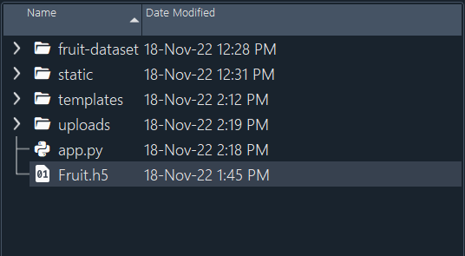

Vegetable

